# COMMUNITY EMPOWERMENT (SCOTLAND) ACT 2015

# FALKIRK COUNCIL ASSET TRANSFER REQUEST FORM

**IMPORTANT NOTES:**

**This is an application form which can be used to make an Asset Transfer request to Falkirk Council.**

**Any Community Body interested in making an Asset Transfer Request is advised to contact the Asset Team on** [**strategicpropertyreview@falkirk.gov.uk**](mailto:strategicpropertyreview@falkirk.gov.uk) **before making the request so that we can discuss your proposal.**

**Please complete the asset transfer request form if the property/land is owned/leased/managed by Falkirk Council.**

**It is essential that you read the** [**Asset Transfer guidance**](https://www.gov.scot/binaries/content/documents/govscot/publications/advice-and-guidance/2017/01/asset-transfer-under-community-empowerment-scotland-act-2015-guidance-community-9781786527509/documents/00513211-pdf/00513211-pdf/govscot%3Adocument/00513211.pdf) **provided by the Scottish Government before making a request.**

**When completed, this form should be emailed to** [**strategicpropertyreview@falkirk.gov.uk**](mailto:strategicpropertyreview@falkirk.gov.uk) **or sent to**

**The Asset Team**

**Falkirk Council**

**4 Stadium Way**

**Falkirk**

**FK2 9EE**

**Section 1: Information about the Community Transfer Body (CTB) making the request**

* 1. Name of the CTB making the asset transfer request

Steins Thistle Football Club

* 1. CTB address. This should be the registered address, if you have one.

Postal address: [REDACTED]

Postcode: [REDACTED]

* 1. Contact details. Please provide the name and contact address to which correspondence in relation to this asset transfer request should be sent.

Contact name: [REDACTED]

Postal address: [REDACTED]

Postcode: [REDACTED]

Email: [REDACTED]

Telephone: [REDACTED]

**✓**We agree that correspondence in relation to this asset transfer request may be sent by email to the email address given above. *(Please tick to indicate agreement)*

*You can ask Falkirk Council to stop sending correspondence by email, or change the email address, by telling them at any time, as long as 5 working days’ notice is given.*

* 1. Please mark an “X” in the relevant box to confirm the type of CTB and its official number, if it has one.

|  |  |  |
| --- | --- | --- |
|  | Company and its company number is …………. |  |
|  | Scottish Charitable Incorporated Organisation (SCIO) and its charity number is ……………….. | SC053719 |
|  | Community Benefit Society (BenCom) and its registered number is ……………………………… |  |
|  | Unincorporated organisation (no number) |  |

**Please attach a copy of the CTB’s constitution, articles of association or registered rules.**

Please note that under The Community Empowerment (Scotland) Act 2015, where a CTB is seeking ownership rather than a lease, the organisation must have at least 20 members. See the Scottish Government’s [Guidance for Community Transfer Bodies.](https://www.gov.scot/binaries/content/documents/govscot/publications/advice-and-guidance/2017/01/asset-transfer-under-community-empowerment-scotland-act-2015-guidance-community-9781786527509/documents/00513211-pdf/00513211-pdf/govscot%3Adocument/00513211.pdf)

* 1. Has the organisation been individually designated as a community transfer body by the Scottish Ministers?

**No X**

**Yes ☐**

Please give the title and date of the designation order:

* 1. Does the organisation fall within a class of bodies which has been designated as community transfer bodies by the Scottish Ministers?

**No ☐**

**Yes ✓**

If yes what class of bodies does it fall within?

Section 80(1)(b) it is a Scottish charitable incorporated organisation the constitution of which includes provision that the organisation must not have fewer that 20 members

1. **Information about the land and rights requested**
   1. Please identify the property/land to which this asset transfer request relates.

You should provide a street address or grid reference and any name by which the land or building is known. If you have identified the land on the relevant authority’s register of land, please enter the details listed there.

*It may be helpful to provide one or more maps or drawings to show the boundaries of the land requested. If you are requesting part of a piece of land, you must attach a map and give a full description of the boundaries of the area to which your request relates. If you are requesting part of a building, please make clear what area you require. A drawing may be helpful.*

Details of Property: Loch Park Pavilion

Address: Loch Park Pavilion, High Bonnybridge

Postcode: FK4 2AS

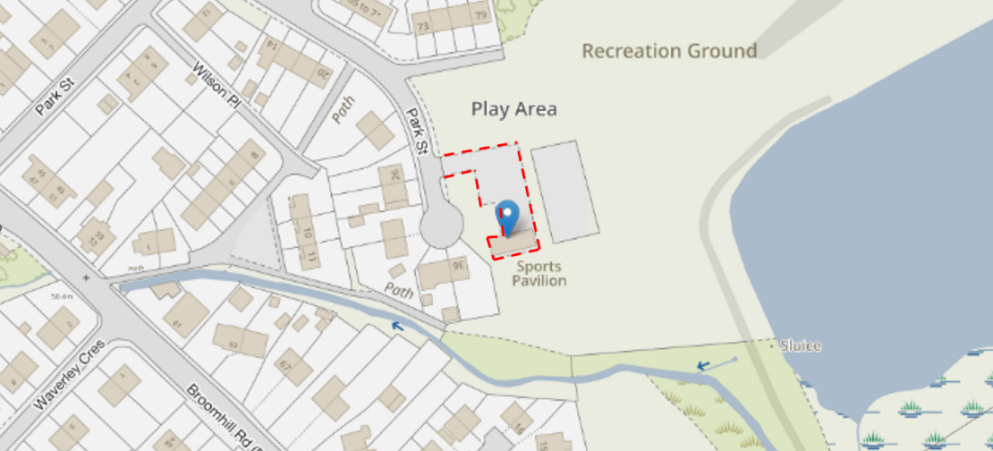

* 1. Please provide the UPRN (Unique Property Reference Number), if known.

UPRN: 136078930

1. **Type of request, payment and conditions**
   1. Please tick what type of request is being made:

**✓**

for ownership (under section 79(2)(a)) - go to section 3A

for lease (under section 79(2)(b)(i)) – go to section 3B

for other rights (section 79(2)(b)(ii)) - go to section 3C

3A – Request for Ownership

What price are you prepared to pay for the land requested?

Proposed price: £1

Please attach a note setting out any other terms and conditions you wish to apply to the request.

|  |
| --- |
| 1. Inclusive of Car Park ownership |

3B – Request for Lease

What is the length of lease you are requesting?

|  |
| --- |
|  |

How much rent are you prepared to pay? Please make clear whether this is per year or per month.

Proposed rent: £ per Annum

Please attach a note setting out any other terms and conditions you wish to be included in the lease, or to apply to the request in any other way.

|  |
| --- |
| Details contained within Business Case |

3C – Request for other Rights

What are the rights you are requesting?

|  |
| --- |
| 1) Exclusive let arrangements for adjacent football pitch.  2) First opportunity to purchase adjacent football pitch with agreement to maintain current purpose of land |

Do you propose to make any payment for these rights?

**Yes ☐**

**No ☐**

If yes, how much are you prepared to pay? Please make clear what period this would cover, for example per week, per month, per day?

|  |
| --- |
| Proposed payment: £ per N/A |

Please set out any other terms and conditions you wish to apply to the request.

|  |
| --- |
| N/A |

1. **Community Proposal** 
   1. Please set out the reasons for making the request and how the land or building will be used.

This should explain the objectives of your project, why there is a need for it, any development or changes you plan to make to the land or building, and any activities that will take place there.

|  |
| --- |
| 4.1.1 Objectives of Project  - Securing facilities and exiting club footballing commitments.  - Increasing local participation in football.  - Supporting Football Performance in the area.  - Providing more local opportunities for participation in community sport. |
| 4.1.2 Why there is a need for your Project?  • To improve health and wellbeing of the local community  • Provide increased social benefits through sport.  • Empower our community and families  • Reduce poverty in the area by providing essential services to help the  wellbeing of the community  • Provide an affordable service for children to help alleviate child poverty in the  area |
| 4.1.3 Will any Development/changes/modifications to the asset be required?  Repairs and upgrade of existing building structure required. Steins Thistle Football Club acknowledge the Survey report prepared by Currie & Brown on behalf of Falkirk Council on 6th October 2023 (Appendix K & L)  Survey report highlighted cost liability and repairs required to bring facility up to current standards as follows.  Steins Thistle recognises Falkirk Councils Liability of Category 1.0 to the value of £3,200.00  SURVEY REPORT |
| 4.1.4 What activities will take place?   * Changing facilities for adjacent Football Pitch. * Storage Room * Disabled Toilet Facilities. * Car Parking |
| 4.1.5. If the asset is to be used by the public, please provide details of lettings policy and opening times.  Asset opening times / policy to be controlled by Steins Thistle Football Club.  Club open to discussions with local community to open facilities for fun days or community events. For example .. (Local Gala / Fun day utilising disabled parking and toilet facilities) Community free to contact club via Facebook or other online channels. |
| 4.1.6 What provision will be provided for people with disabilities?   * Facility will be maintained to current standards. * Facility currently built on a single roadside level with no stairs. * Refurbishment of facility will include the needs of disabled members including toilet provisions. |
| 4.1.7 Any other relevant information?   * In keeping with current standards at Allandale Steins Thistle would propose to install and maintain an external Heart Defibrillator contained within an external metal controlled locker. |

Benefits of the proposal

* 1. Please set out the benefits that you consider will arise if the request is agreed to.

Local Authorities are permitted to dispose of property at less than market value where there are wider public benefits to be gained. This is set out in the Disposal of Land by Local Authorities (Scotland) Regulations 2010. These public benefits are listed below.

In this section, please explain how the project will benefit your community, and others. Please refer to the Scottish Government [guidance](https://www.gov.scot/binaries/content/documents/govscot/publications/advice-and-guidance/2017/01/asset-transfer-under-community-empowerment-scotland-act-2015-guidance-community-9781786527509/documents/00513211-pdf/00513211-pdf/govscot%3Adocument/00513211.pdf) on how the Council will consider the benefits of a request.

|  |
| --- |
| Please explain how the project will benefit your community by detailing how your project will promote or improve:-  4.2.1. Economic development/income generation  ie. Please include details of any job creation or **volunteering and training** opportunities that will be available as a result of the Asset Transfer. Also details of how your organisation will involve the **local community** and of any incentives that may be available to encourage the local community to use the proposed services.  Our football club provides essential services that might otherwise be inaccessible due to the financial constraints of our local community.  We are a volunteer run club and the opportunities we provide to volunteers will help residents develop new skills and gain valuable work experience. Volunteering can serve as a stepping stone to future employment, enhancing the employability of individuals and contributing to the overall skill level of the community. Offering educational and training programs can help bridge the gap for those who are not in full-time education or employment.  Our football club fosters social cohesion and well-being, which are essential for a thriving economy.  - Asset transfer gives scope for club to grow and remain with Allandale / High Bonnybridge  Area.   * Volunteering opportunities for new coaches into the club. * Training opportunities within the SFA coaching pathway. * Incentives available for local community during through Football camps during school holidays. * Accessible football for all through SFA pathway |
| * + 1. Regeneration   i.e. Please include details of whether your organisation will contribute to the **physical regeneration** of the area, and how your proposal will impact the regeneration of the area, in terms of volunteering or employment, giving examples.  By taking community ownership of Loch Park Pavilion, we will look to regularly maintain the interior and exterior of the pavilion. We will paint the exterior in order to improve the aesthetic of the pavilion and improve signage.   * Steins Thistle are willing to commit resource and funding into the Loch Park project. * Existing Trustees & Coaches mentoring new coaching teams to enable growth in grassroots football. * Funds also planned to regenerate the physical appearance of the building which as described in recent survey in need of urgent improvement. |
| * + 1. Public Health   i.e. How likely is the proposal to improve the Public Health of the Community, in terms of **physical and mental health**, for example through volunteering, training, or taking part in activities, giving examples.  By improving the overall health of the community, our group aims to help ease the pressure on public and social services, and on other facilities. By engaging in regular social activities, our community can reduce stress, improve mood, and gain a sense of purpose.  Physical activities we provide for children of different age groups help maintain physical health and mobility for all those who attend them. Together, these benefits contribute to a healthier, happier, and more connected community. When individuals have access to programmes that support their social, mental, and physical health, they are less likely to require intervention from public services. This proactive approach to community health not only benefits individuals, but also reduces the burden on public resources, allowing them to be allocated more effectively, to areas where they are needed the most.  Regular social activities can reduce stress, improve mood, and provide a sense of purpose, which can decrease the reliance on health services.  Offering educational programs on nutrition, mental health, and preventative care can empower residents to take control of their health. The community centre can collaborate with local health services to provide accessible health screenings, vaccinations, and other essential services. This can be particularly beneficial in ensuring that vulnerable populations receive the care they need.  The Asset transfer would help support physical and mental health wellbeing of the local community.  Steins Thistle currently provides an estimated 11,600 hours of sport through training & matches which has proven records in physical and mental well being. |
| * + 1. Social Wellbeing   i.e. How will the proposal improve the Community's Social Well-Being and mental health, or how might it improve the **learning offer and activities** available in the area? Please give brief examples of these activities.  The activities and social interactions facilitated by Steins Thistle will contribute significantly to both the mental and social wellbeing of our community. We provide a safe space for the local community to meet and engage with each other through our training, matches, activities and events.  Offering volunteer opportunities within the football club can enhance social cohesion and provide residents with a sense of purpose. Volunteering can help individuals develop new skills, gain confidence, and feel more connected to their community.  By facilitating intergenerational activities, the centre can bridge the gap between different age groups. Intergenerational activities can foster mutual understanding and respect and provide opportunities for learning and mentorship.  As per details on public health benefits identified, the club provides an environment for all to engage socially and learn new personal skills across all age groups. |
| * + 1. Environmental Wellbeing / Environmental Benefits   i.e. Will the proposal bring green / environmental benefits and / or have an impact on the **local environment**? Will it help mitigate the effects of climate change? If so please give details.  We plan to continue to work in an environmentally conscious way to reduce our carbon footprint on the environment and local community.  We will look to implement energy-efficient technologies and sustainable practices so the pavilion can reduce its environmental impact.  We can engage the community in environmental initiatives, such as clean-up drives, tree planting events, and recycling programs. These activities can foster a sense of community pride and responsibility, encouraging residents to take an active role in protecting their local environment.  Steins Thistle plans to upgrade the facility including an upgrade of the current electrical systems detailed within the survey assessment. |
| * + 1. Does your project contribute to the reduction of inequalities?   i.e. Will the proposal enable the community to access activities not otherwise available; will these activities be available at an affordable rate; how will your organisation work with other local providers to **reduce inequalities**?  The Scottish Football Association is responsible for setting the standards and values to apply throughout football at every level in Scotland.  It is the ambition of Steins Thistle Football Club to achieve “Best in Class” application of these standards.  Football is for everyone; it belongs to, and should be enjoyed by, anyone who wants to participate in it.  The aim of this policy is to ensure that everyone is treated fairly and with respect and that football is equally accessible to all.  All Participants should abide and adhere to this Policy and to the requirements of the Equality Act 2010.  Steins Thistle Football Clubs commitment is to promote inclusion and to confront and eliminate discrimination whether by reason of age, gender, gender reassignment, sexual orientation, marital status or civil partnership race, nationality, ethnic origin, colour, religion or belief, ability or disability, pregnancy and maternity and to encourage equal opportunities.  This Policy is fully supported by the Steins Thistle Executive Committee who are responsible for the implementation of this policy.  Steins Thistle Football Club will not tolerate harassment, including sexual harassment, bullying, abuse or victimisation of a Participant, which for the purposes of this Policy and the actions and sanction applicable is regarded as discrimination, whether physical or verbal. The Club will work to ensure that such behaviour is met with appropriate action in whatever context it occurs.  Steins Thistle Football Club commits itself to the immediate investigation of any allegation, when it is brought to their attention, of discrimination and where such is found to be the case, The club will require that the practice stop and impose sanctions as appropriate.  Steins Thistle Football Club is committed to inclusion and anti-discrimination and raising awareness and educating, investigating concerns and applying relevant and proportionate sanctions, campaigning, achieving independently verified equality standards, widening diversity and representation and promoting diverse role models are all key actions to promote inclusion and eradicate discrimination within football. |
| 4.2.7 Will local people be engaged in the use and management of the Asset?  A “community of interest” may not represent the people living near to the asset. Please provide evidence of how **local people and communities** will be engaged in the use and management of the asset, and how they have been consulted.    Refer to section 10 of the business case. (Local Support/ Community Engagement)  On Friday 21st February 2025 a Survey was launched for 1 week on the proposed community asset transfer of Loch Park Pavilion to Steins Thistle Football Club.  Links to survey were posted on the following channels  - Bonnybridge Banter Facebook Group (16k Followers)  - Banknock Facebook Group (5.5k Followers)  - Steins Thistle Club Facebook Page (1.2K Followers)  - Steins Thistle Team Facebook Pages (approx. 1K Followers)  - Shared by multiple individuals on Facebook & WhatsApp channels  Facebook post on a single Steins Thistle Club Facebook post achieved 8094 Views and 1518 points of engagement.  Survey achieved 121 formal responses  Multiple levels of Support and ideas of how to support / engage with the community received and acknowledge for future considerations.  -“Roots and the other food banks around seem to have big community support going in Bonnybridge, maybe see if the boys can potentially help out at the food bank in some way and help plaster it on social media as a little team up”  - “Bonnybridge schools host football competitions within the school grounds however it would be lovely to see somewhere like this open up and provide a decent sized and properly maintained pitch for the kids to play on.”  - “Engage with those who might not get represented as much ie young women, for a girls football team”.  - “Rental to other local Bonnybridge groups/schools could help towards maintaining the facilities in the long term”.  - “There is space to widen the car park. This would alleviate some of the issues. Litter is awful too, so if this facility was to be brought back to life, refuse disposal would need to be in place. More bins would be a start.”  - “Anyone wishing to invest in community assets should be fully supported by the local authorities. Once complete, hopefully it could be used by more than by footballers.”  - “Would be good too get the park boxed of with too stop dogs getting on park.”  - “Hopefully local businesses will support the Club in the work required to bring the Loch Park facility back to a usable condition. Local sports facilities have been lost over a number of years due to lack of maintenance and funding. This proposal will help to regenerate the provision of much needed pitches in the area”. |
| 4.2.8 How will you monitor whether the Asset Transfer is benefiting the community?  ie. Will you survey the users / invite feedback / compare user numbers with a baseline etc  Player membership number and Partnership agreements with external football academies are reviewed as part of the club AGM and will assess the ongoing benefit at that period of time.  Policy will be prepared to survey Community and local partners to determine if Steins Thistle as a club are fulfilling needs within the community and to seek improvement in engagement along with any further opportunities.  This will be done in the form of online surveys. Process as used on the initial CAT application feedback. |
| 4.2.9 Any other relevant information? |

Restrictions on use of the land

* 1. If there are any restrictions on the use or development of the land, please explain how your project will comply with these.

Restrictions might include, amongst others, environmental designations such as a Site of Special Scientific Interest (SSI), heritage designations such as listed building status, controls on contaminated land or planning restrictions.

|  |
| --- |
| Unaware of any restrictions – Falkirk Council to confirm |

Negative consequences

* 1. What negative consequences (if any) may occur if your request is agreed to? How you propose to minimise / reduce these?

You should consider any potential negative consequences for the local economy, environment, or any group of people, and explain how you could reduce these.

|  |
| --- |
| Pre-existing issue of traffic on Park Road has been highlighted along with size of car park.  See Business Case – Appendix M  The following policy is proposed to easy any impact on local residents.  a) Car Park capacity to be maximised for Trainings & Match days  b) 15-20min gap to be positioned between any event to mitigate congestion.  c) Visiting Players & Supporters directed to Reilly Street & Broomhill for street parking (Excluding disabled or individuals with specific needs).  d) Specific notification to all attendees to avoid parking on Park Street or Wilson Place.  AERIAL VIEW |
|  |

Capacity to deliver

* 1. Please show how your organisation will be able to manage the project and achieve your objectives.

This could include the skills and experience of members of the organisation, any track record of previous projects, whether you intend to use professional advisers, etc.

4.5.1 Has your organisation or any of its members managed projects or owned / leased property/land prior to this?

Yes **✓**

No ☐

Please provide details of:

4.5.2 Skills and experience of the members of the organisation

Steins Thistle has owned and managed its own Pavilion & Football pitch since 1970.

Some of the current trustees were part of the original team established, and it is estimated that we have around 200+ years combined experience operating the club and associated facility.

Pavilion size at Loch Park is comparable to Allandale and would be repaired and maintained to a similar level.

[NAMES REDACTED]

TABLE OF MEMBERS

4.5.3 Do you intend to use professional advisors? Please provide details.

CVS Falkirk – Supporting CAT application

Steins Thistle has engaged the services of Blackadder & McMonagle to conclude the legal aspects of our organisation assuming ownership of the property and land as part of the community asset transfer.

The organisation is also going to employ an accountant to audit our yearly accounts to satisfy the requirements of being a SCIO.

4.5.4 Do you currently lease/manage a property from Falkirk Council? If yes, please provide details.

- Stirling Road Pitches – Pitch Lets

- Denny High School Pitch – Pitch Lets

4.5.4 Please detail how you plan to manage the building?

For example opening and closing the building / managing lets / will you have staff etc?

Steins Thistle staff will control Opening and Closing facility.

4.5.5 Please provide any other information you think may be relevant.

See Business Case for further details.

1. **Level and nature of support**
   1. Please provide details of the level and nature of support for the request, from your community and, if relevant, from others.

This could include information on the proportion of your community who are involved with the request, how you have engaged with your community beyond the members of your organisation and what their response has been. You should also show how you have engaged with any other communities that may be affected by your proposals.

5.1.1. What community engagement has taken place to help develop your business plan? Please provide evidence, for example any completed surveys, questionnaires, letters of support, minutes of public meetings etc.

On Friday 21st February 2025 a Survey was launched for 1 week on the proposed community asset transfer of Loch Park Pavilion to Steins Thistle Football Club.

Links to survey were posted on the following channels

- Bonnybridge Banter Facebook Group (16k Followers)

- Banknock Facebook Group (5.5k Followers)

- Steins Thistle Club Facebook Page (1.2K Followers)

- Steins Thistle Team Facebook Pages (approx. 1K Followers)

- Shared by multiple individuals on Facebook & WhatsApp channels

Facebook post on a single Steins Thistle Club Facebook post achieved 8094 Views and 1518 points of engagement.

Survey achieved 121 formal responses Section 10 of the business case details completed survey and associated results.

29.8% of responses were received by residents living within 0.5 mile radius of the Loch Park Pavilion.

94.44% of respondents living in High Bonnybridge support the proposal for Steins Thistle to achieve successful community asset transfer of Loch Park Pavilion.

When assessing the internal playing and coaching staff we can confirm that approx. 75% to 80% of total club live within Bonnybridge, Denny, Longcroft, Haggs & Banknock. (3 mile radius). All voting members of the club also live within this radius.

Sample of messages supporting the applications are as follows….

Sample of responses

- “Support local teams and good for the community”

- “this will be a great asset for the team and also the local community”

- “A great facility enjoyed by many in and around the community- Would be great to see this kept going and further improvements made to enable many more years of use and enjoyment.”

- “If Steins were to take it over and transform it into a functioning, quality space for both Steins Thistle and the wider community, so many more users would benefit from it. It would make complete sense to have someone invest time and money into it rather than see it going to ruin!”

- “Great community club. Facilities for the kids. Local.”

- “Communities need facilities like these to grow and maintain a community spirit . The facility would help support mental and physical health and wellbeing not just for the immediate community but the surrounding areas. Children and adults need somewhere to go to be active, meet people and have a sense of belonging”

- “We need to keep our local facilities to offer local people opportunities. My son’s youth team used loch park a great deal when he was growing up. We need this facility to continue”.

- “Steins do alot for all ages in the community, this would be a great asset to them”.

- “More places needed for children to go and get them off the streets causing mayhem”

- “Lot of history and memories on that park would love to see it used for many more years to come”

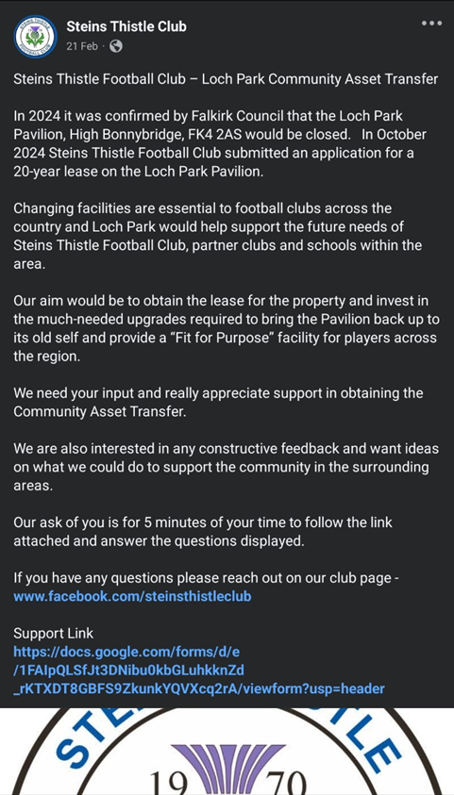

5.1.2 Have you consulted with other local stakeholder groups or agencies? Please provide evidence.

Consulting with local community stakeholders was identified as a crucial step in the application process to ensure that Steins Thistle was being transparent, inclusive and meets the needs of the local community.

The online survey was agreed to be the best way to communicate and reached over 8094 local people and gave access to other stakeholder groups access details of the proposed Community Asset Transfer of Loch Park Pavilion to Steins Thistle. Contact details for the club remain open through Facebook

Bonnybridge Football Club are the main known community stakeholder and aware of the intentions by Steins Thistle to apply for CAT however no written evidence available at this time. We are aware that Bonnybridge Football Club are pursuing Loch Park and have recently been successful in the application of asset transfers relating to Jenny Park & Anderson Park facilities.

The pavilion has been used exclusively for football by Bonnybridge Football Club historically and as such no other stakeholders exist to contact direct ie the Pavilion hasn’t been exposed to ongoing community usage for many years (if ever!)

By engaging in a process of this nature Steins Thistle have disclosed intentions and received fantastic feedback from the community. Through this consultation process we can ensure that the community asset transfer is beneficial to the local community, supported and sustainable in the long term.

5.1.4 Have you been in contact with any other communities or community groups

that may be affected? Please give details.

By taking ownership of Loch Park, this will strengthen the ability to meet the needs of the people that live in the local area, increased opportunities for local volunteering, participation and support. This has been proven in recent years with Amateur team member coaching U15 players and U15 Players coaching U9 players.

This process has been advertised on various Facebook platforms over a number of years and open to all members within the local community.

The online survey reached over 8094 local people and gave access to other stakeholder groups access details of the proposed Community Asset Transfer of Loch Park Pavilion to Steins Thistle. Contact details for the club remain open through Facebook

Bonnybridge Football Club are the main known community stakeholder and aware of the intentions by Steins Thistle to apply for CAT however no written evidence available at this time. We are aware that Bonnybridge Football Club are pursuing Loch Park and have recently been successful in the application of asset transfers relating to Jenny Park & Anderson Park facilities.

The pavilion has been used exclusively for football by Bonnybridge Football Club historically and as such no other stakeholders exist to contact direct ie the Pavilion hasn’t been exposed to ongoing community usage for many years (if ever!)

5.1.5 Please provide any other information you think may be relevant.

Not at this time.

1. **Financial Viability of Project**

Your Business Plan should contain full information about the financial viability of the project, evidencing that the organisation will be able to sustain the project in the long term.

Please submit

* at least 1 year’s audited accounts to evidence your organisations financial stability (if available)
* where audited accounts are not available (for instance for new groups) please provide a bank statement.
* a projected 5 year income and expenditure account
* a cash flow forecast for the proposed asset transfer.

|  |
| --- |
| 6.1 Please outline the Policies and Procedures your organisation has in place to govern the group’s finances  See enclosed Business Plan for details |

1. **Funding**
   1. Please outline how you propose to fund the price or rent you are prepared to pay for the land, and your proposed use of the land.

If you intend to apply for grants or loans, you should demonstrate that your proposals are eligible for the relevant scheme, according to the guidance available for applicants*.*

7.1.1 Please show your calculations of the costs associated with the transfer of the land or buildings and your future use of it, including any redevelopment, ongoing, maintenance and the costs of your activities. All proposed income and investment should be identified, including volunteering and donations.

See attached Business Plan for details

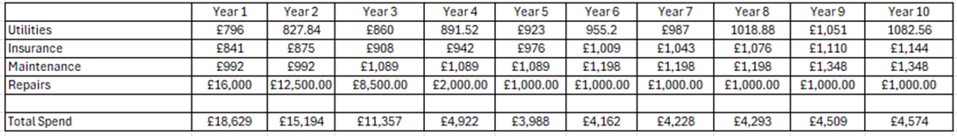

7.1.2 Please supply details of what funding you have received so far, and of any conditions attached to it.

Last 5 years club income streams

Last 5 Years Audited Accounts Supplied.

ACCOUNTS


7.1.3 Please supply details of any funding you have applied for but have not yet received a response or decision. Please include timescales if known.

No current funding applications in place.

7.1.4 Details of any other funding you will have access to? i.e. voluntary contributions, borrowing etc.

Club have multiple organisations that have provided match funding. These include British Gas, William Grant & Sons and RSA Insurance.

Club main back up facility is the Club Asset Fund which at last fiscal held circa £38,000

7.1.5 Please outline your funding strategy if you have one, as well as any other relevant information.

Club 5 year funding projection

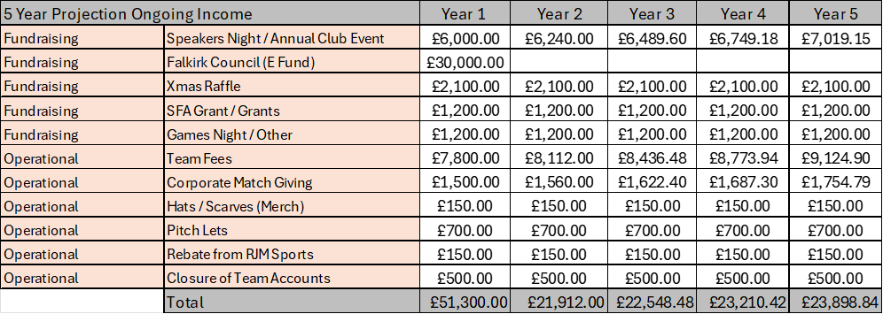

1. **Enablement Fund**

Falkirk Council will hand the building over wind and watertight and compliant. However, this is quite light-touch and would involve (for example) patching of a leaky roof. For more significant building works, groups can apply to the Enablement Fund, to pay for capital improvements such as energy efficiency improvements or larger capital renewals which support the viability of the project going forward. **Only capital items are eligible**. Running repairs are revenue costs and are not eligible. You are strongly advised to email [strategicpropertyreview@falkirk.gov.uk](mailto:strategicpropertyreview@falkirk.gov.uk) to confirm eligibility criteria before you submit this application.

Requests to the Fund must be supported by estimates / quotations from professionals which should be provided as supporting documents.

**Please provide details of your request to the Enablement Fund, if applicable.**

|  |  |  |
| --- | --- | --- |
| **Enablement Fund request for larger capital renewals which support the viability of the CAT** | | |
| Item | Estimate Provided By | Amount not more than (including VAT) |
| Replace Cisterns x 2  Replace Toilets x 3  Install Cold Water Tap in store room.  Change faulty valves in Boiler room.  Replace damaged shower.  Secure and lag pipework | [REDACTED] | £1,900.00 |
| Scaffolding.  Remove unsound boss & loose existing roughcasting.  Fix diamond mesh over all elevations.  Fix perimeter bellcast, corners & stop beads.  Base coat all elevations.  Apply top coat and finish with chosen aggregates.  Replace guttering and downpipes on full front elevation.  Clear site & waste management | [REDACTED] | £9,950.00 |
| Repair & Upgrade internal & external electrical systems.  Full Lighting upgrade.  Additional sockets added to store room.  New electrical heaters  Full emergency lighting system. | [REDACTED] | £2196.09 |
| Total Including VAT | | Circa £14,046.09 |

**Checklist of accompanying documents**

To check that nothing is missed, please tick which additional documents are accompanying this form.

Section 1 – You must attach your organisation’s constitution, articles of association or registered rules

Section 2 – Any maps, drawings or description of the land requested

Section 3 – Note of any terms and conditions that are to apply to the request

Section 4 – Any additional evidence regarding your proposals, their benefits, any restrictions on the land or potential negative consequences, and your organisation’s capacity to deliver.

Section 5 – Evidence of community support

Section 6 – Financial – Copies of accounts, forecasts, etc

Section 7 – Funding – Copy of Business Case etc

Section 8 – Enablement Fund – copies of estimates

**Declaration**

Two office-bearers (board members, charity trustees or committee members) of the community transfer body must sign the form. They must provide their full names and home addresses for the purposes of prevention and detection of fraud.

This form and supporting documents will be made available online for any interested person to read and comment on. Personal information will be redacted before the form is made available.

**We, the undersigned on behalf of the community transfer body as noted at Section 1, make an asset transfer request as specified in this form.**

**We declare that the information provided in this form and any accompanying documents is accurate to the best of our knowledge.**

Name [REDACTED]

Address [REDACTED]

Date 01/10/2024

Position Chairman

Signature (CC’d in Email)

Name [REDACTED]

Address [REDACTED]

Date 01/10/2024

Position Treasurer

Signature (CC’d in Email)